**[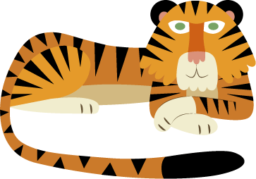](http://www.attleborough-jun.norfolk.sch.uk/index.phtml?d=220661)****Attleborough Primary School**

Inspire Achieve Grow

Knowledge organiser

**Year 1 Spring 1**

Africa is a continent, split into lots of different countries. Kenya is one of these.

Kenya is on the equator so is very hot all year round. Instead of hot/cold seasons, it has wet and dry seasons.

Kenya has lots of fascinating wildlife which is very different to the wildlife we have in the UK.

The four main compass points are north, south, east and west.

Kenya is twice the size of the UK and has a varied landscape.

Kenyan culture is hugely diverse.

Let’s go on Safari!

Children will learn about the seven continents and five oceans of the world. They will learn about different climates. Children will learn about the animals they might see on a Kenyan safari. Children will be introduced to map work and learn about compass points. They will discover features of African landscapes and the different groups of people who live in Kenya. Children will use this knowledge to compare Kenya to the United Kingdom.

**Vocabulary**

Safari, oceans, Kenya, Africa, map, continent, country, equator, weather, climate, dry season, wet season, temperature, herbivore, carnivore, compass, north, south, east, west, landscapes, mountain, volcano, savannah, valley, culture, Masaai, warrior, hunt, predator, herbivore, carnivore.

**Key knowledge**

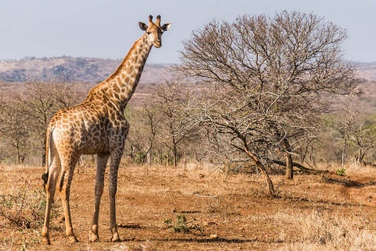

**Kenyan animals’ appetites!**

**Lions**- *Hunt* other animals to eat.

**Rhinoceros**- Are *herbivores*.

**Giraffes**- Eat leaves on trees.

**Elephants**- Eat different plants.

**Leopards**- *Pray* on animals for food.

**Buffalos**- Eat grass.

**Zebras**- Eat grass.

**Others Kenyan animals** **include**: Flamingos, hippos, gazelles, vultures, cheetahs and hyenas.

**The continents:**

North America, South America, Antarctica, Africa, Europe, Asia, Australasia.

**The oceans:**

Pacific Ocean, Southern Ocean, Atlantic Ocean, Indian Ocean, Pacific Ocean, Arctic Ocean.

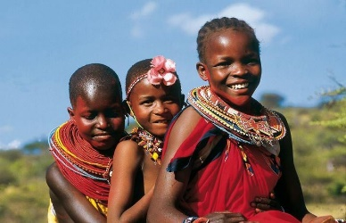 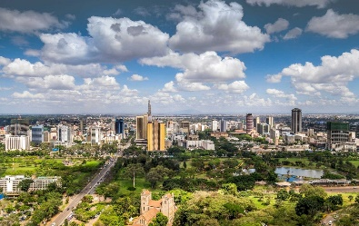

**Kenyan Landscape**

Kenya has beautiful sandy beaches, snow-topped mountains, volcanoes, savannahs (tropical grassland), valleys (low areas of land surrounded by mountains), large cities (Nairobi is the capital city) and small villages.

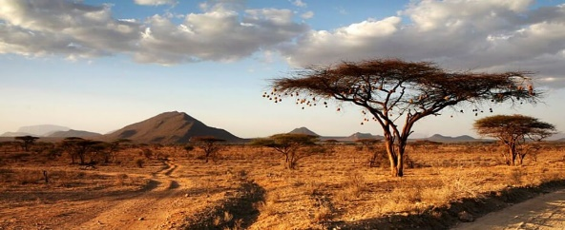

**Kenyan culture:** Some people live modern lifestyles in big cities, such as Mombasa. Other people live in villages, such as farmers. The Maasai people live in traditional tribes, just like their ancestors.



Animals (including humans)

In this unit children learn about different types of animals and the ways in which they can be grouped. They begin to sort animals and names some key similarities and differences. They learn how to describe animals and use the correct vocabulary for body parts. They learn about different animals’ diets and compare these to humans’.

**Vocabulary**

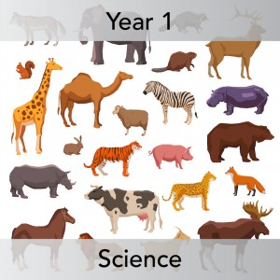

**Animal groups**

**Fish**- Live in water and have gills, scales and fins.

**Reptiles**- Have cold blood and are born on land.

**Birds**- Have feathers and are born out of eggs.

**Amphibians**- Born in water but can live on land when grown.

**Mammals**- Drinks milk when it’s a baby and has hair.

Animal, human, carnivore, omnivore, herbivore, fish, reptiles, birds, amphibians, paw, tentacle, tusk, claw, flipper, antler, hoof, gills, fin, beak, whiskers, wings, horn, trunk, whiskers, beak, feathers, fur, scales, skin.

* There are lots of types of animals on our planet, including humans.
* Humans share some characteristics with some animals.
* Animals can be categorised based upon their features.
* Different types of animals eat different types of foods- some eat meat, some vegetation, some eat both.

**Key knowledge**

**Different appetites**

**Carnivore**- Carnivorous animals only eat meat. They have to catch these animals to eat them. Examples of such animals include lions, sharks, polar bears and snakes.

**Herbivore**- Are animals which only eat plants. These can be flowers, grass, nuts or fruit. Cows, rabbits and elephants are all herbivores.

**Omnivores**- Eat plants and meat! For example chickens, pigs and humans!

