**[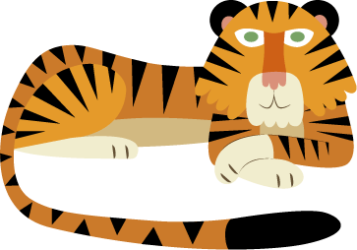](http://www.attleborough-jun.norfolk.sch.uk/index.phtml?d=220661)****Attleborough Primary School**

Inspire Achieve Grow

Knowledge organiser

**Year 1 Spring 2**

**Vocabulary**

**Down On the Farm**

In this unit the children will find out what a farm actually is before looking at some of the different types of farms, namely arable, livestock and dairy. They will explore what happens on each type of farm and consider why farms are so important. Children will identify what the four points on a compass mean and learn how to use them to navigate around a map of a farm. Children will identify the difference between urban and rural areas. They will learn key information about healthy eating, where their food comes from and will prepare their own fruit salad!

There are several different types of farm.

**Arable** farms - means that they grow crops in their fields.

On arable farms, the farmers harvest the crops they have grown once they are ripe. They can then sell the grains to factories so that they can turn them into flour or other useful things, or they can sell the fruits and vegetables to shops to be sold.

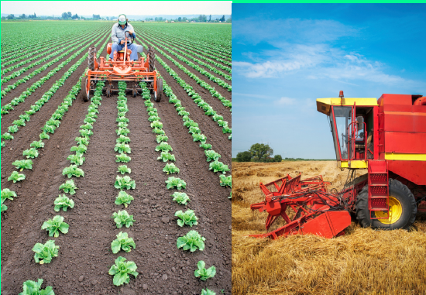

Farm – arable, livestock, dairy.

Pasture, crops, produce

Urban – city, town / Rural - countryside

Autumn, Spring, Summer, Winter - seasons

North, South, East, West – compass / direction

Barn, orchard, field, sty, pen, hen house

**Key knowledge**

Some farms focus on raising animals instead of crops. These are called **livestock** farms.

Livestock farmers rear animals for meat or for other products such as wool or eggs.

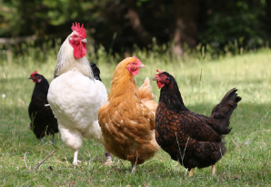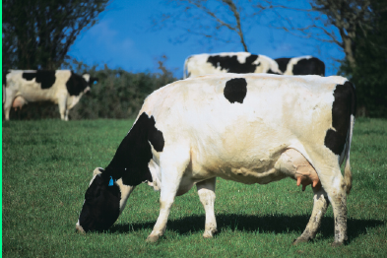

Food hygiene

Another type of farm that raises animals is a **dairy** farm.

Dairy farms use the milk from cows, goats and other animals to create products like cheese, yogurt and butter (as well as milk of course!). Farmers in the past had to always milk their animals by hand but today most dairy farms have machines to help them.

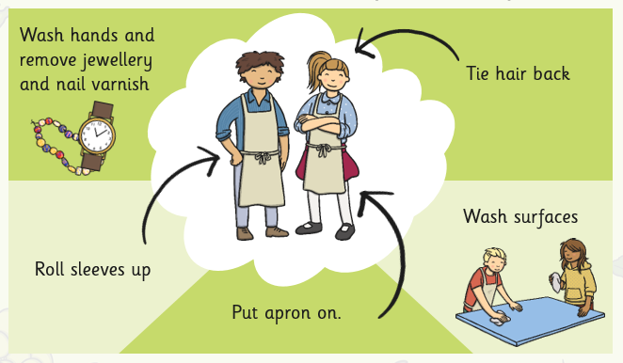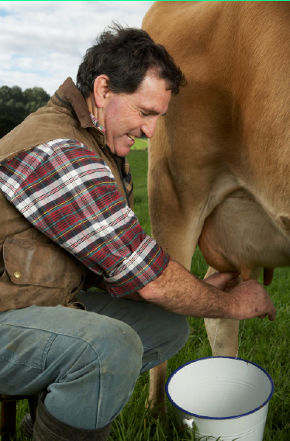



**Mammals** have fur or hair. They are vertebrates which means they have a back bone. They are warm blooded which means they can keep their body temperature the same in all weathers. They give birth to live young and feed them with milk.

**Vocabulary**

Animals (including humans)

In this science unit children will identify, name and describe a variety of common animals, including mammals, birds and reptiles and compare and describe some of their features. They will consider similarities and differences between some fish and amphibians and will also learn about some fish/amphibian life cycles. Children will find out about the diet of a variety of different animals. They will consider the needs of a variety of animals, and explain how best to care for them.

**Animal groups**

**Fish**- Live in water and have gills, scales and fins.

**Reptiles**- Have cold blood and are born on land.

**Birds**- Have feathers and are born out of eggs.

**Amphibians**- Born in water but can live on land when grown.

**Mammals**- Drinks milk when it’s a baby and has hair.

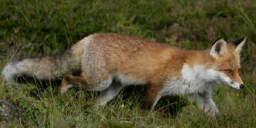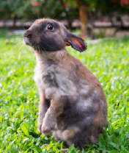

Mammals in the United Kingdom include: dog, cat, rabbit, hedgehog, squirrel, bat, fox, badger, weasel, mouse deer and lots more!

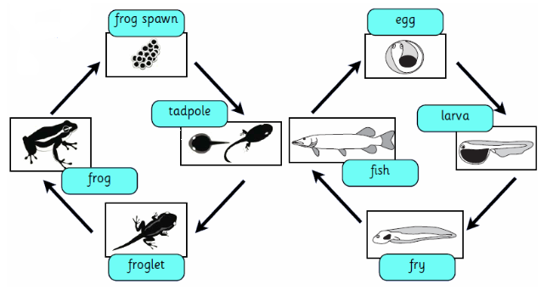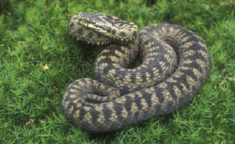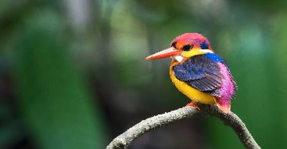

Life cycle

**Fish and amphibians**

Water is very important for both these animals. Fish live in water their whole lives, but amphibians spend time on land. Both animals are vertebrates which means they have backbones.

Similarities and differences

A **reptile** has dry, scaly

skin. They are cold-blooded vertebrates. Most reptiles lay eggs. Reptiles can be snakes, lizards, crocodiles, turtles or tortoises

A **bird** has feathers, wings and a beak. They are warm-blooded and lay eggs. Most birds can fly. Birds are vertebrates. This means they have backbones.

**Key knowledge**

**Different appetites**

**Carnivore**- Carnivorous animals only eat meat. They have to catch these animals to eat them. Examples of such animals include lions, sharks, polar bears and snakes.

**Herbivore**- Are animals which only eat plants. These can be flowers, grass, nuts or fruit. Cows, rabbits and elephants are all herbivores.

**Omnivores**- Eat plants and meat! For example chickens, pigs and humans!

