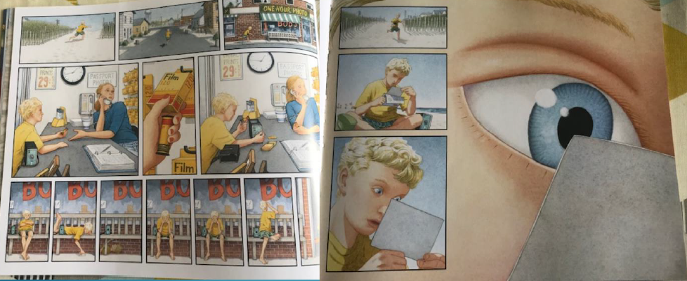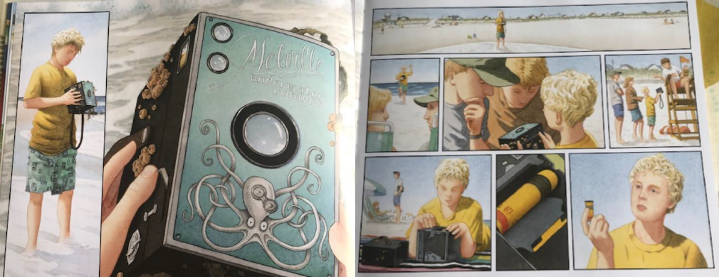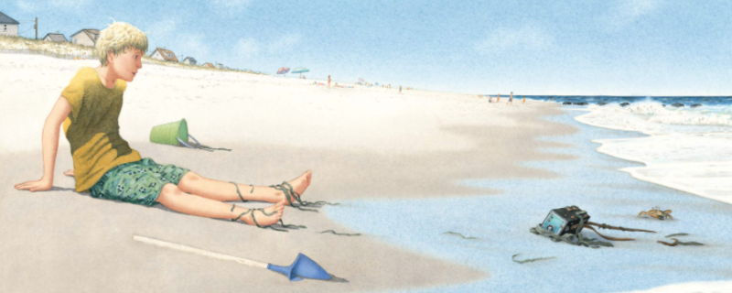Friday 15th January

**Can I make deductions and inferences from pictures?**

What do you know? (What can you see?)

What would you like to know?

What do you think you know? (You will need to use the word because in your sentences)