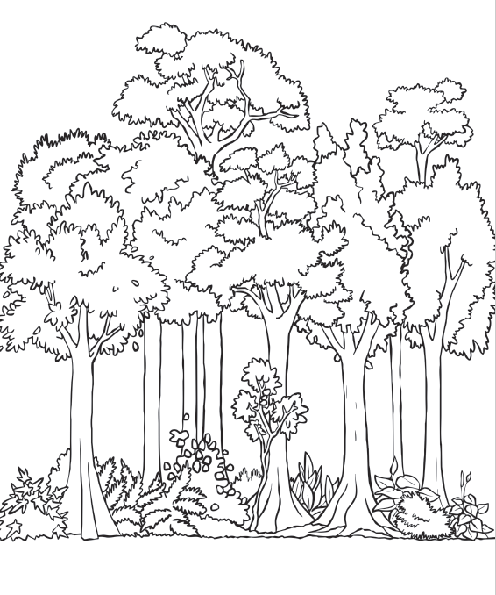
Label the layers of the rainforest

Choose your challenge!
Bronze: Label the layers - forest floor, understory, canopy, emergent.
Silver: Label the layers, then write a definition of what each layer means
Gold: Label Layer then write a definition of what each layer means as well as a fact about each layer eg: which animals live in each layer
Relax whilst you colour your rainforest in!
If you don’t want to print this picture off, you could add your layer labels to your rainforest picture you drew last week!

