Bronze – Complete questions 1-10. Use the place value grid to help you
Silver – Complete as many questions as you can. Think carefully about how the digits will move and check your answers!
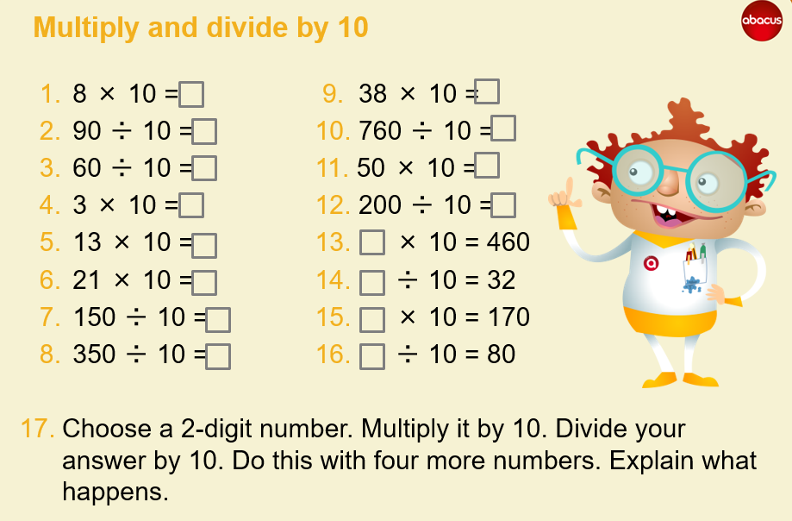
Gold – Complete questions 6-16. Have a go at Q17. Don’t forget to explain what happens

