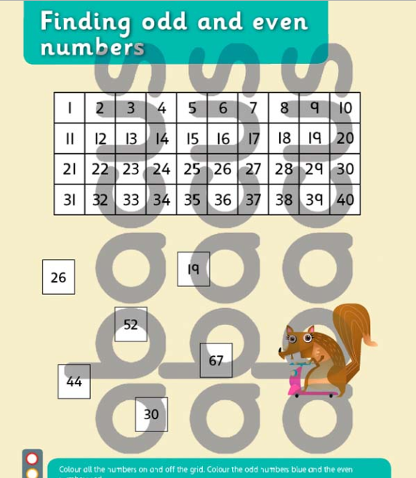
Colour the odd numbers blue and the even numbers yellow.

