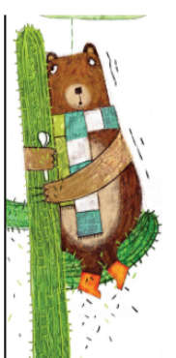**Option 1 – Phonics**

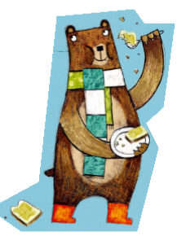**Word bank**

worm

work

word

pearl

learn

Earth

finger

letter

bird

girl

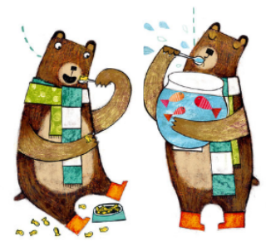curl

hurt

