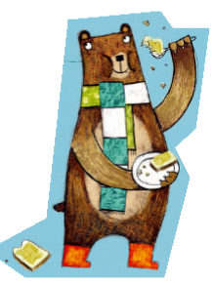
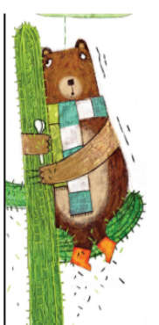
Option 2 – Phonics
Word bank
worm
work
worship
pearl
learn
Earth
search
finger
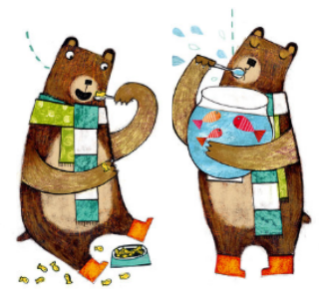
hammer
letter
number
bird
girl
skirt
turnip
curl
hurt

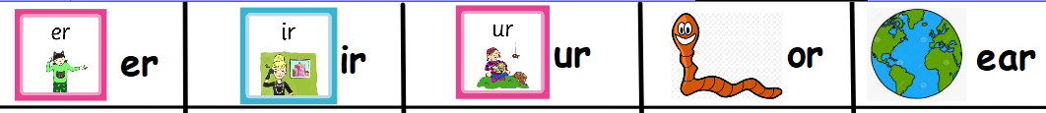

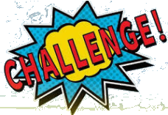
performance
rehearsal
mermaid
surprised
circus

