Phoneme spotter- wh
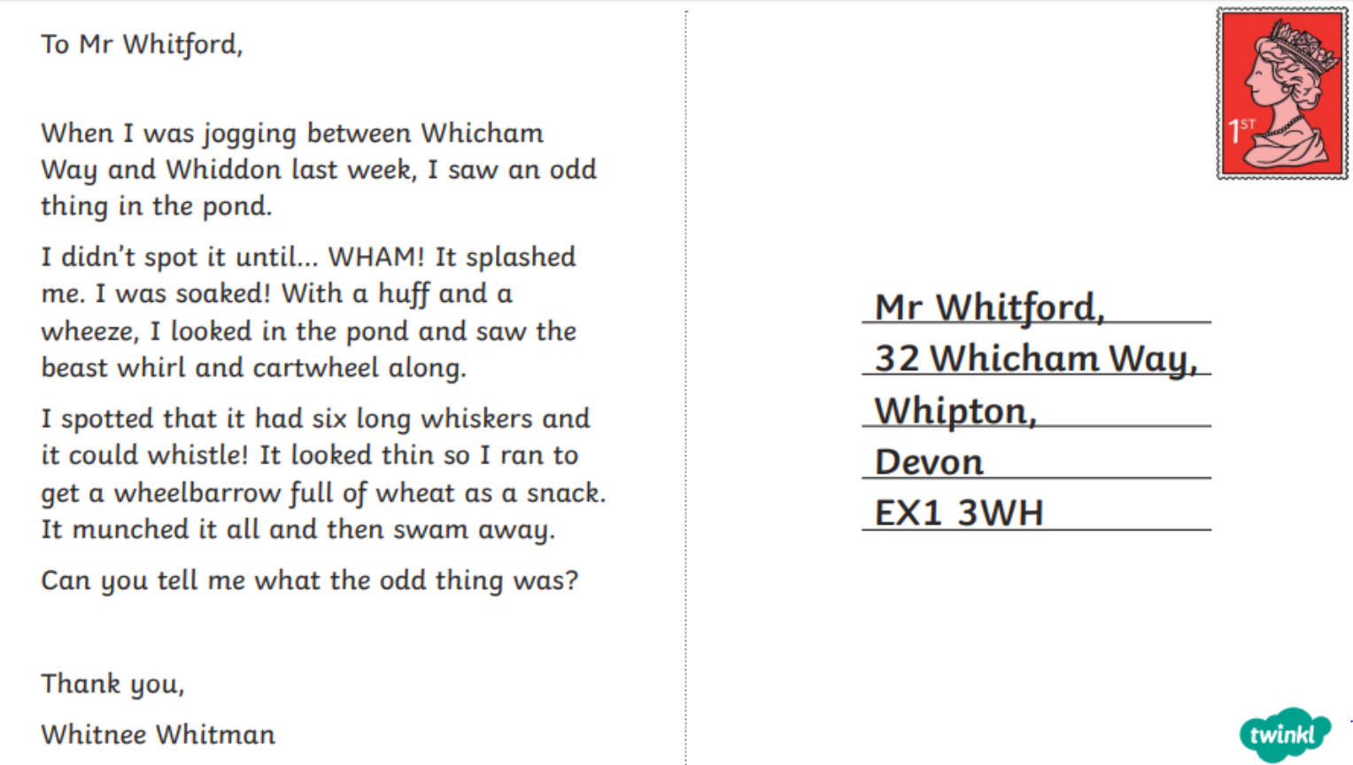
Read the postcard and highlight the ‘wh’ words. Practise writing some of these.

