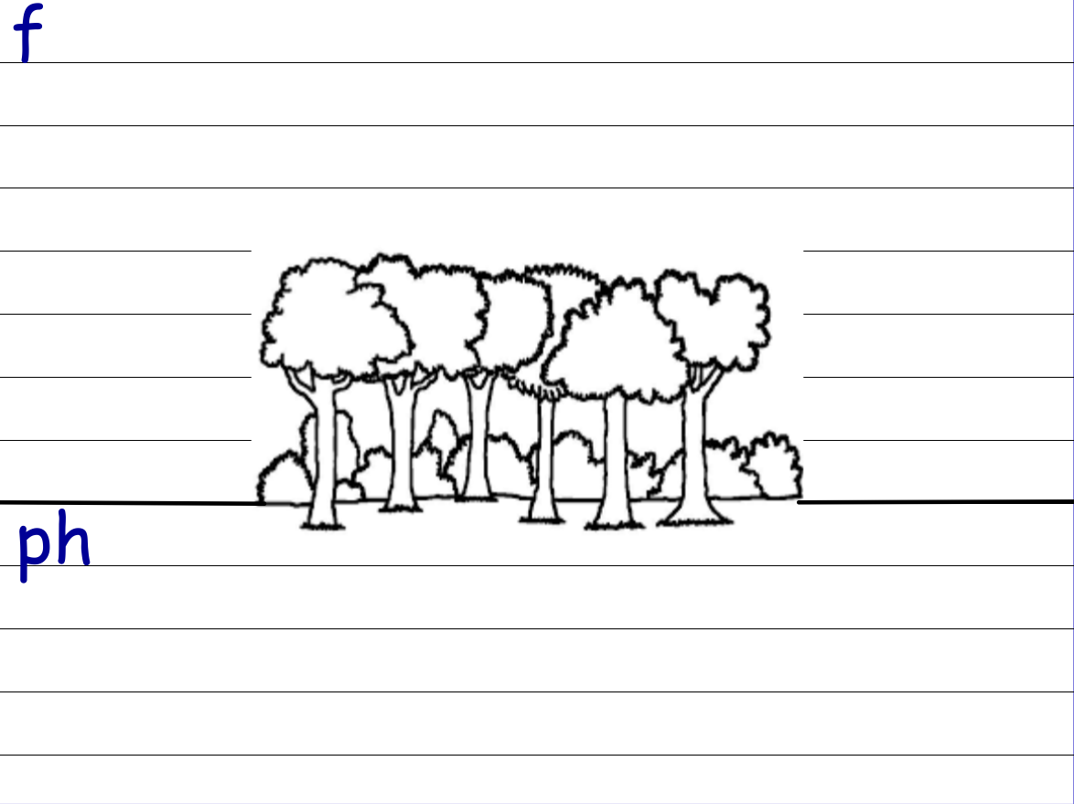

fog | fan | fun | full
dolphin | elephant | telephone | trophy
stuff | huff | puff | fluff

