The Bears’ House

One day a boy called Sam and his sister Molly tiptoed into
the woods. They knew they shouldn’t go into the woods
because their mum had warned them not to. She had told
them about wild bears that had been found in the woods.
“Look out!” cried Sam as a large boulder came rolling
towards Molly. She jumped aside just in time. They went
around a pond, over a bridge and spotted an old house.
Sam and Molly went closer to it.

Then there was a loud bang. “Did you hear that sound coming from the house?” asked Molly. “We should not go inside,” replied Sam.
Suddenly Molly felt something tapping her on the shoulder.
“I think it would be a good idea to go back home now,” she
whispered to Sam. So they both turned round and started
to run back over the bridge. They didn’t dare to stop in case
a bear could catch up with them! They couldn’t wait to get
back to their own house. Sam and Molly sat down on the
sofa, feeling out of breath. They promised their mum they
wouldn’t ever go back into the woods again. And they never
did!

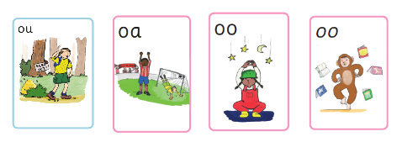
Find and colour any words in the story that use these digraphs.

