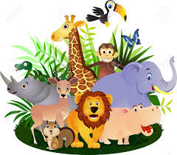

Phil is having holiday fun
Travelling in Scotland.
See the dolphins follow the boat
Click! Take a photo!
Phil is having holiday fun
Travelling in Kenya.
On safari, elephant herds,
Click! Take a photo!
Phil is having holiday fun
Travelling in Egypt.
Land of Pharaohs, Look at the Sphinx!’
Click! Take a photo!

Option 2
Read the poem and highlight any ‘f / ph’ words you can find. Practise writing these using your phonics to help sound them out.
Can you illustrate the poem using the clues in the text?

