Year 1 – Independent/Home Learning Tasks
Thursday 7th January 2021
Thank you for joining yesterday’s live sessions. Remember, if you get stuck or technology does not work, don’t worry. There is lots of learning you can still do, but it is important that you do some learning every day so that you don’t get behind.
Your parents can email us if they have any problems.
jbanks@attleboroughprimary.org.uk
ltuvey@attleboroughprimary.org.uk
Any resources you need for lessons will be on the school website. Click on the ‘parent’ tab, then ‘home learning’ and your ‘class’ page. Here are today’s learning tasks!
Live Lessons (via Teams)
Phonics: We look forward to you joining us for phonics at:  9:45  We are learning:  “ear”  PLEASE HAVE A PENCIL AND PAPER READY TO USE DURING THE LESSON.  Follow up activity after lesson:  Option 1:  Add the zips and buttons to the ‘ear’ words. Can you draw a picture to go with each word e.g. for the word ‘early’, you might draw a picture of yourself in bed.  Option 2:  Can you sort the real words from the alien words?  You can either cut the words out or write them.  Choose one of the real words and write it in an ‘amazing’ sentence. Don’t forget…  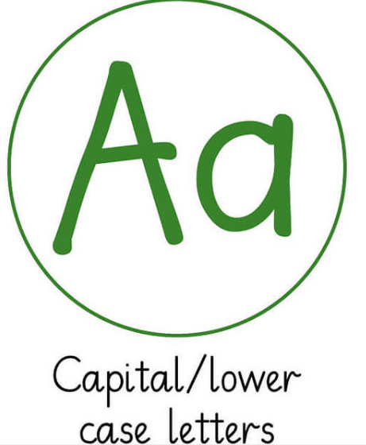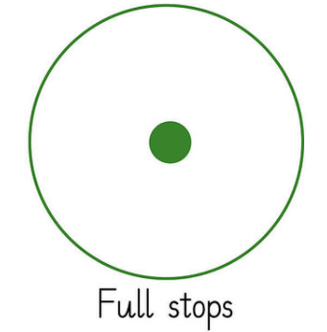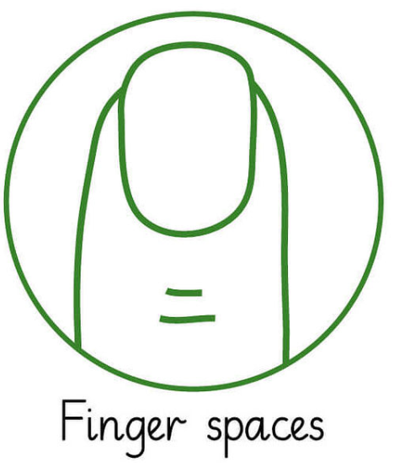 | Maths: We look forward to you joining us for maths at:  10:45  We are learning:  Two more and two less  Follow-up activity after lesson:  Option 1:  Workbook page 2  Finding one more and one less than a multiple of 10  Option 2:  Workbook page 3  Finding 2 more and 2 less.  It would also be useful to print the 0-30 number line and 100 square. | Topic: We look forward to you joining us at:  1:15  We are learning:  To locate Africa and Kenya on a map  Follow-up activity after lesson:  Option 1: Worksheet 1A  Option 2: Worksheet 1B  Option 3: Worksheet 1C  Extra challenge: Complete worksheet 1D. Can your grown- up help you to answer the questions?
Spellings | Reading | Be Active
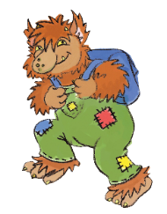  Tricky words for this week:  are  out  there  your  were  where  Practise spelling them (LOOK, SAY, COVER, WRITE, CHECK). When confident, have a go at writing them in a sentence | Practise your sounds everyday- make a set of flashcards with each of the phase 2 and 3 sounds on. See if you can get them all really quickly!  Too easy? Make a set of the phase 5 sounds!  See separate resource for the sounds. | Cosmic yoga:  The Masked Singer | A Cosmic Kids Yoga Adventure! - Cosmic Kids  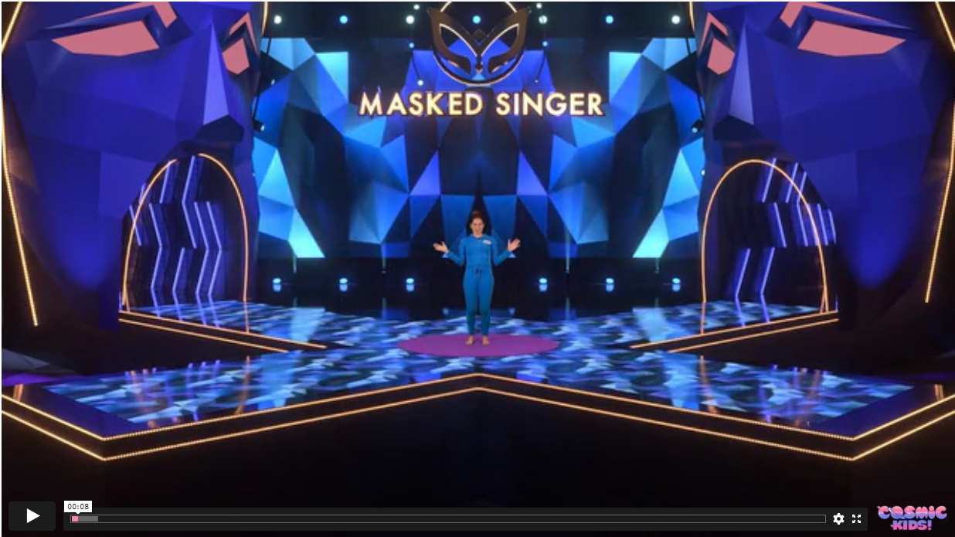
Other
Reading
Please try to read something every day. We are currently unable to change reading books however you could try some of the e-books on the Oxford Owl site.
To access the e-book collection at home
Go on: http://www.oxfordowl.co.uk/
Children click 'My class login' on top right.
Username - 4CDM
Password – grow

Daily handwriting practice for this week
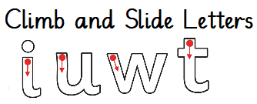

Are these letters sat on the line? Are they starting from the starting button? Are they ending in the correct place? Are they all the same size?

Useful Websites for extra learning
BBC Bitesize https://www.bbc.co.uk/bitesize
Maths www.topmarks.co.uk
Phonics https://www.phonicsplay.co.uk/
Computing https://www.ictgames.com
Reading https://www.booktrust.org.uk/
Internet Safety: https://www.thinkuknow.co.uk
Well-Being https://www.activenorfolk.org/active-at-home-kids

