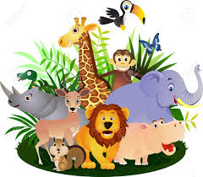

Phill is having holiday fun
Travelling in Scotland.
See the dolphins follow the boat
Click! Take a photo!
Phill is having holiday fun
Travelling in Kenya.
On safari, elephant herds,
Click! Take a photo!
Phill is having holiday fun
Travelling in Egypt.
Land of Pharaohs, Look at the Sphinx!’
Click! Take a photo!

Option 2:
Write your own caption for ‘f’ using ‘f’ words AND ‘ph’ words. Use the ph words in the poem for inspiration!

