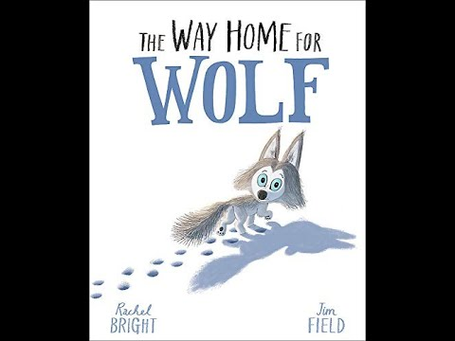
- Which word describes what Wilf loved to be?

kind fierce playful annoying

- What did Wilf LONG to be?

- Why did Wilf find it hard to keep up with the pack?

- Can you name three of the animal friends Wilf meets along his journey?

- Can you think of three words to describe how Wilf feels at the end of the book?

