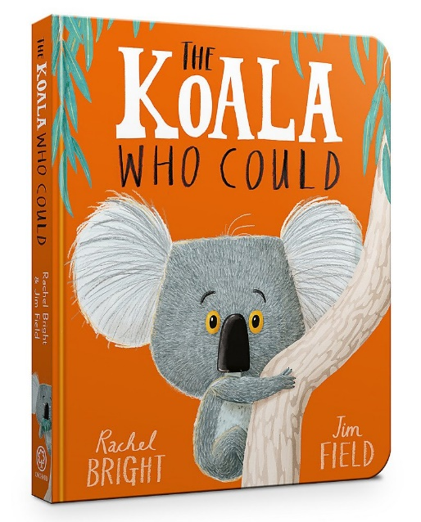

Questions

- Can you think of three things that Kevin did not like about being down on the ground?

- Where is Kevin’s favourite place to relax?

- What noises did the tree make as it came crashing down?

- Can you think of something that you have been nervous to do? Did you do it anyway? How did that feel?

