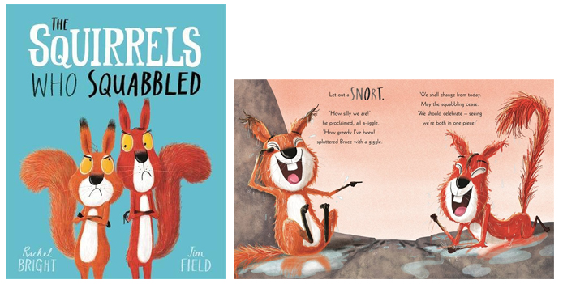

The squirrels who squabbled
by Rachel Bright and Jim Field

- Look at the picture at the top of the page. How has the way the squirrels feel about each other changed in the second illustration?

- On the first page, can you find a word which means very tall?

- How do you think ‘Plan-ahead Bruce’ got his name?

- What is a good word to describe the squirrels’ behaviour on page 12?

kind generous loving selfish

- What lesson do you think the two squirrels learned?

- What did you enjoy best about the book?

