Can I respond to an illustration and make a prediction?

Today, we will be making some annotations/ predictions by looking at the front cover of our new text. The text is named ‘Lila and the Secret of Rain.’

Challenge one:
Complete the questions in the grid by using the front cover (positioned in the middle) to help you.

Who do you think Lila is? | Where do you think that the story is set? | Do you think this is a fiction or non-fiction text?
 | 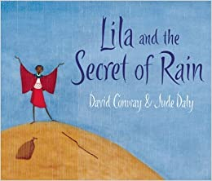
Describe the clothes that the character is wearing. |  | What do you think the secret could be?
Does this image remind you of any other book? | Describe the setting. | What can you see in this illustration?

Challenge two:
Write a paragraph about what you think will happen in the story.

I predict that ……. because …...

