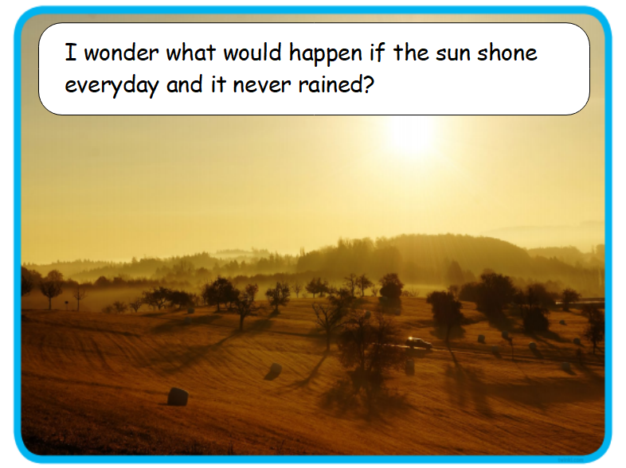
Writing – Option 2
Try to use the word
‘because’ somewhere
In your paragraph.

