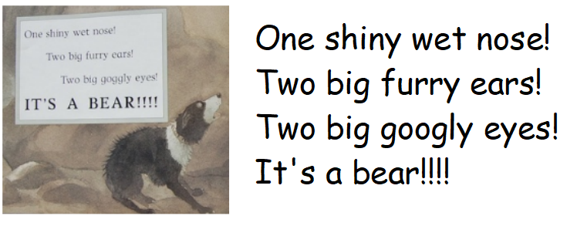
Writing task

Draw a picture of the bear using the clues in the text. Label the features in your picture.
Can you identify the words which are adjectives?

