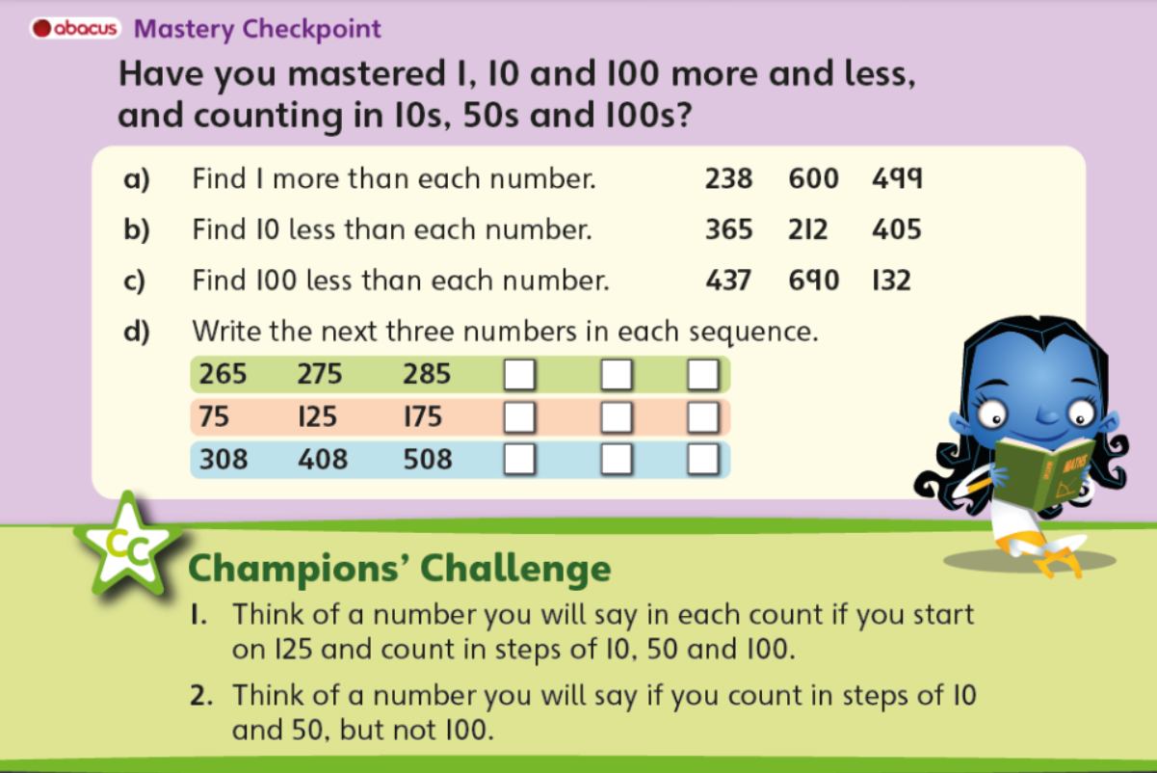
Year 3 Maths – Tuesday 12th January

Choose your challenge!
Bronze: Questions a-d but remove the hundreds digits from the numbers to give you 2 digit numbers to solve eg: 238 becomes 38
Silver: Questions a-d
Gold: Questions a-d + Champions challenge

