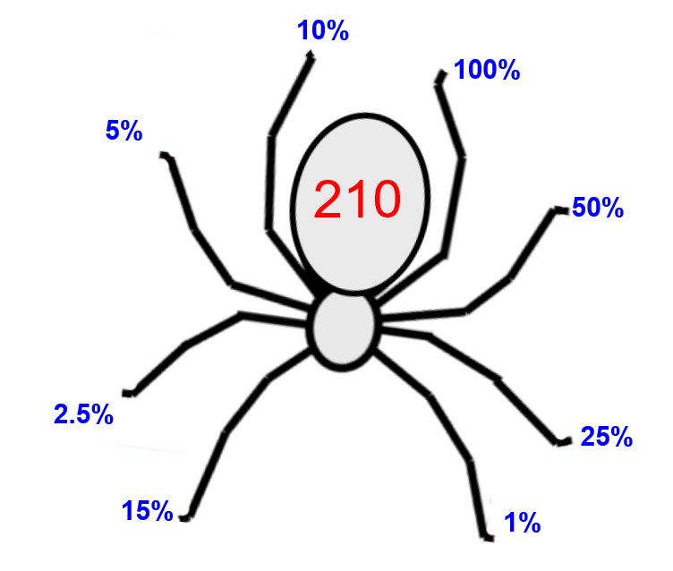

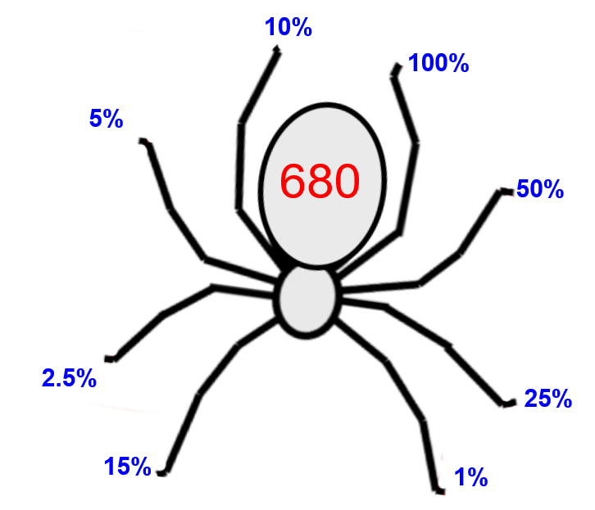

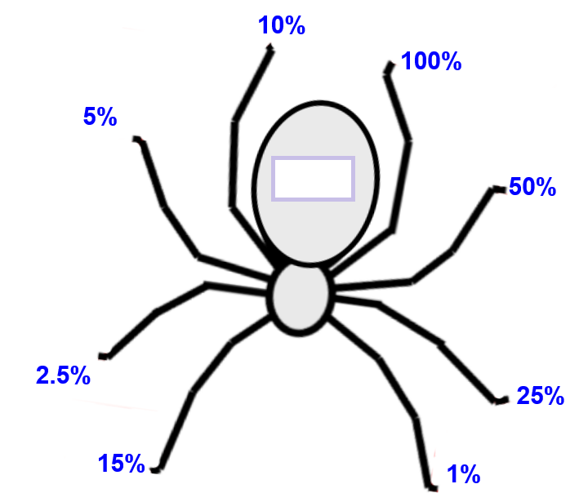

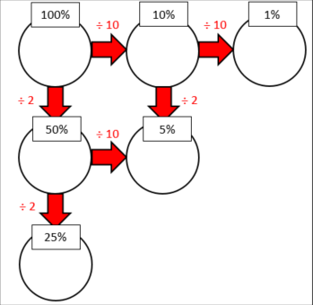

Silver and Gold

Explain using mathematical language why you only need to find out the percentage amounts listed in the bubble method to find any possible percentage. You can use examples to illustrate your point.

