Remember: Can you simplify your fraction to see if it is equivalent? 30/100 = 3/10… 10/50= 1/5…
50% = 50/100 = 5/10 (= 1/2) Is another way of saying 50 out of 100 or 50 divided by 100.

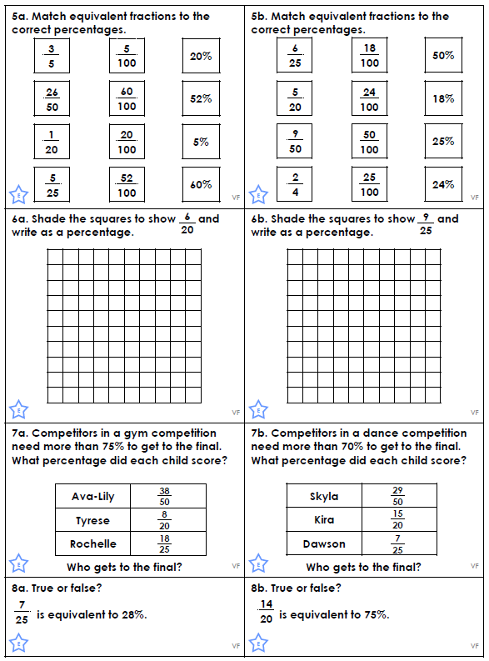

Answers
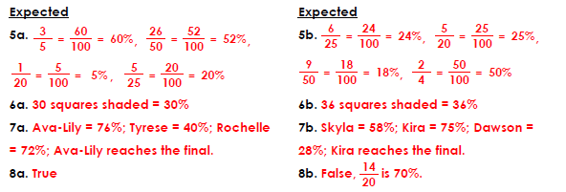

Extension
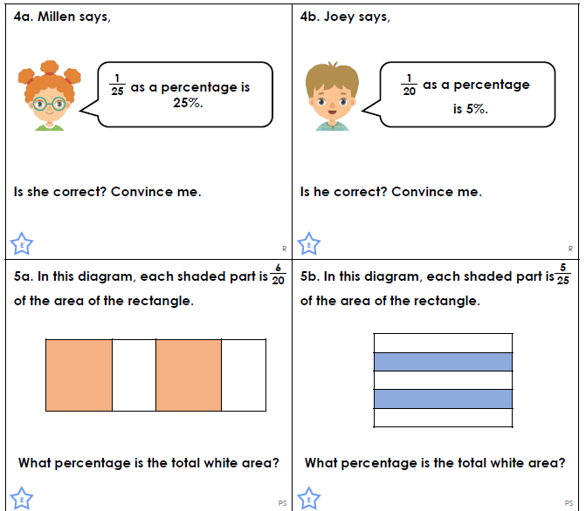
Answers
