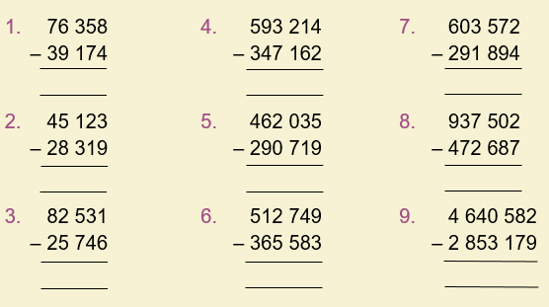

Write a subtraction question using 7 digit numbers with 1 exchange and 1 with 2 exchanges. Don’t be afraid to use trial and error!
As an example, the following question has 1 exchange:
Write your subtraction answers in here:
