Write examples of subtraction questions, using 7 digit numbers with 1 exchange, with 2, 3, 4 and 5 exchanges. Don’t be afraid to use trial and error!
As an example, the following question has 1 exchange:
Write your subtraction answers in here:
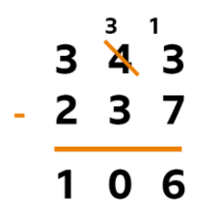

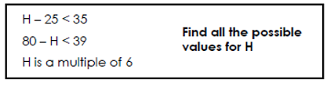
Write your answers in here:

Write your answers in here:
