Answer even numbered questions, using the partitioning method.

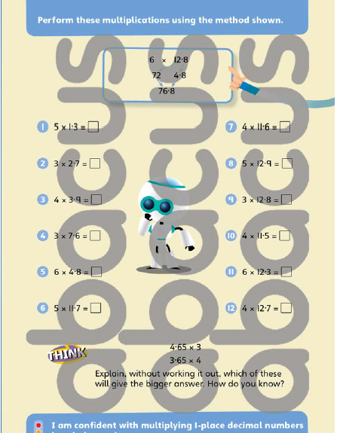

Gold Extension Task
Work in pairs, with someone in your family or over Teams/ Zoom/ FaceTime with a friend?
Roll a 0-6 dice three times and put the digits into a calculation in the form:
. x so that your answer is as close to 12 as possible. Calculate the answer.
The person closest to 12 wins the round. Play 3 rounds.

If you do not have a dice at home you can use this one online!
Roll a Die! Online Dice! (online-stopwatch.com)

