Remember: Angles in a triangle add up to 180°. Angles in a quadrilateral add up to 360°. Opposite angles are the same. Arrowed or dashed lines signify parallel or lines that are the same length.
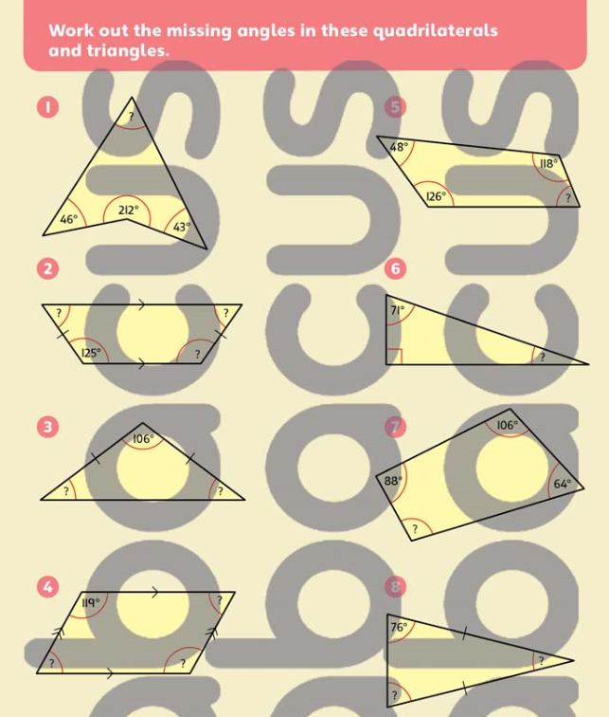

Answers
