Remember (n -2) x 180 = Sum of all interior angles.
E.g. Pentagon (5 sides) (5-2) x 180 = 520°
Opposite Angles are the same.
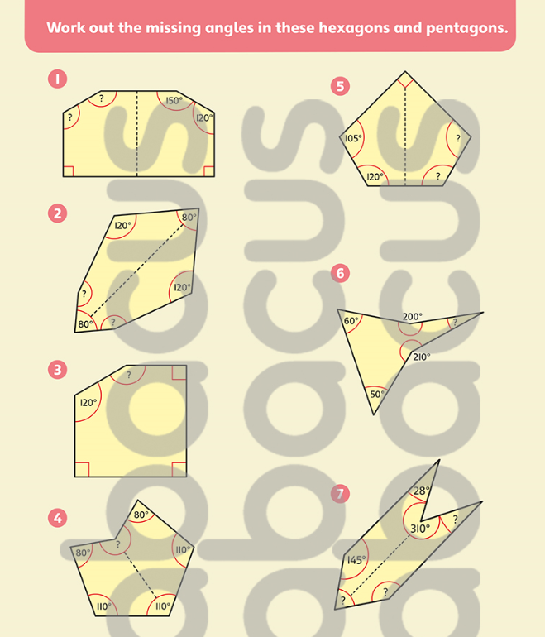

Answers
