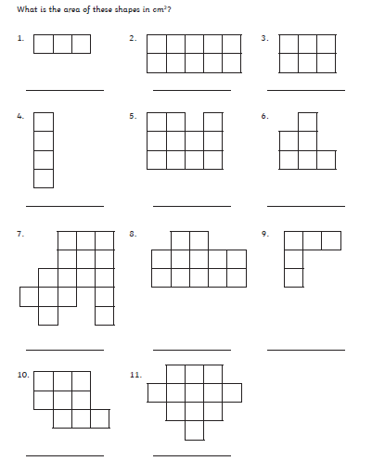

Hint: You could use colour to find the shapes within the shape…