Testing 10s

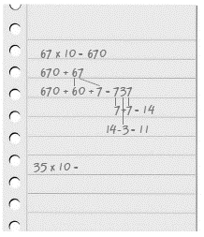
- Write a 2-digit number.
Multiply it by 10.

- Add these two numbers together.

- Add the 100s and 1s digits (the two outside digits, 7 and 7).
Then subtract the 10s digit (the middle digit).

- Repeat with ten different 2-digit numbers.

- What patterns do you find?
Can you predict what the answer will be depending on the two numbers you add first?

