Remember: To plot coordinates accurately, you go “along the corridor and up the stairs”. (X, Y)
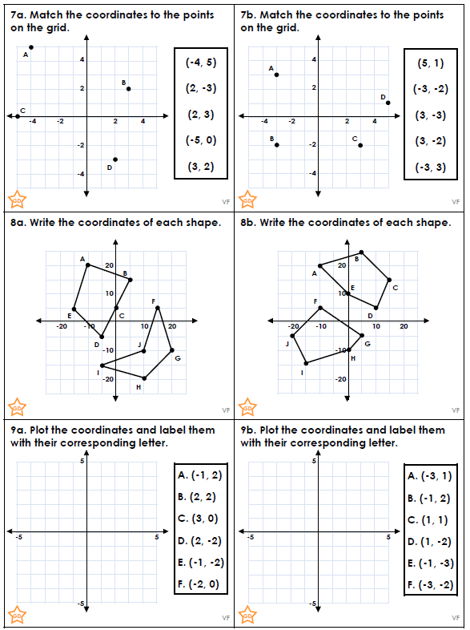

Answers
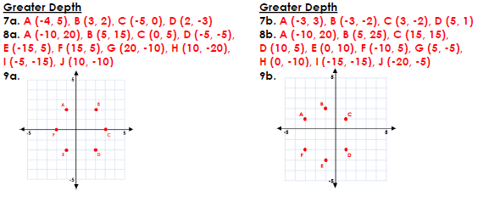

Extension
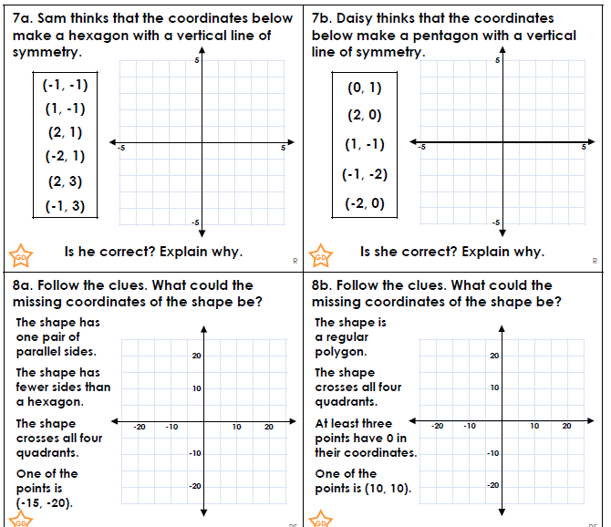

Answers

