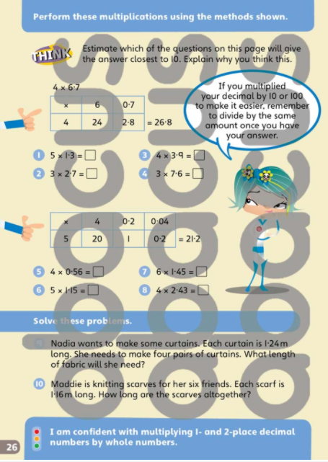

Here are some grids to help you set out your question.

x

Remember to add these 2
numbers to find the final =
answer

x
x

x
x

x
x

Which method do you prefer to use when multiplying decimals?
The partitioning? Or the grid?

Whichever one is fine – whichever one you prefer to use and feel most confident with is the one I would recommend to use in future

