Try to work out how many hours old you are…

Clue – Think of how many years old you are…….
How many days in a year….
How many hours in a day…

Select 5 questions to answer, showing your working for each one.

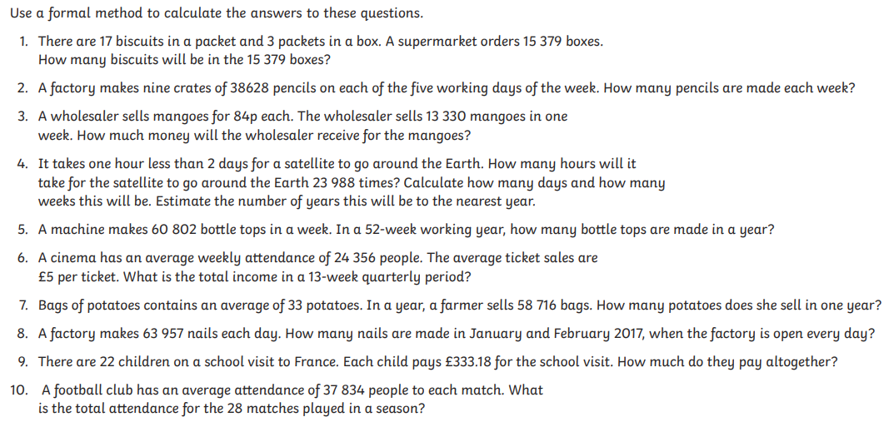

Answers

