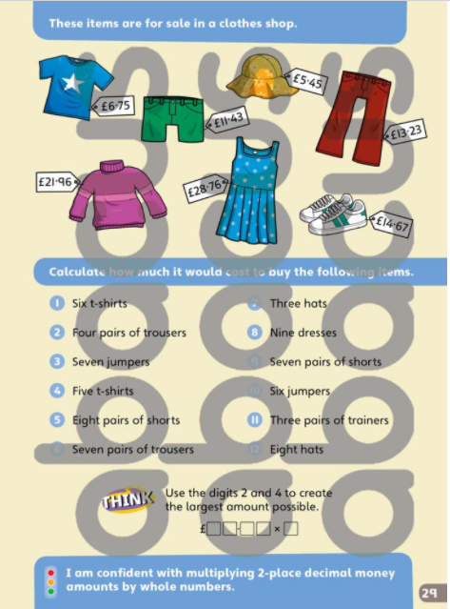
Extension Task: Use a 0-6 dice and roll 4 times to generate a multiplication in the form of _ x £ _ . _ _ your answer needs to be as close to £50 as possible
Roll a Die! Online Dice! (online-stopwatch.com) (link to online dice if you do not have one at home)
Write your possibilities in here and then circle your closest amount to £500.

