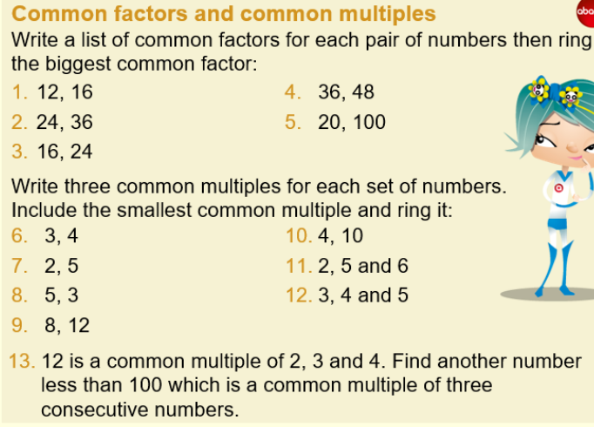

Extension:

Factor-multiple Chains

Stage: 2
Here is an example of a factor-multiple chain of four numbers:
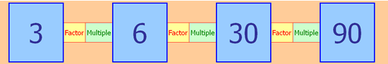
Can you see how it works? Perhaps you could make some statements about some of the numbers in the chain using the words "factor" and "multiple".
In these chains, each blue number can range from 2 up to 100 and must be a whole number.
You may like to experiment with the spreadsheet on the laptop which allows you to enter numbers in each box. Perhaps you can make some more chains for yourself.
Can you answer these questions:
1. What are the smallest blue numbers that will make a complete chain?
2. What are the largest blue numbers that will make a complete chain?
3. What numbers cannot appear in any chain?
4. What is the biggest difference possible between two adjacent blue numbers?
5. What is the largest and the smallest possible range of a complete chain? (The range is the difference between the largest and smallest values.)

