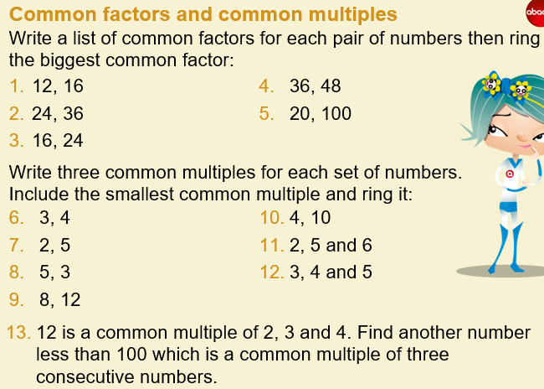

For Q11 and Q12 you could show your answers in a triple venn diagram instead of a list which looks like the one below:
