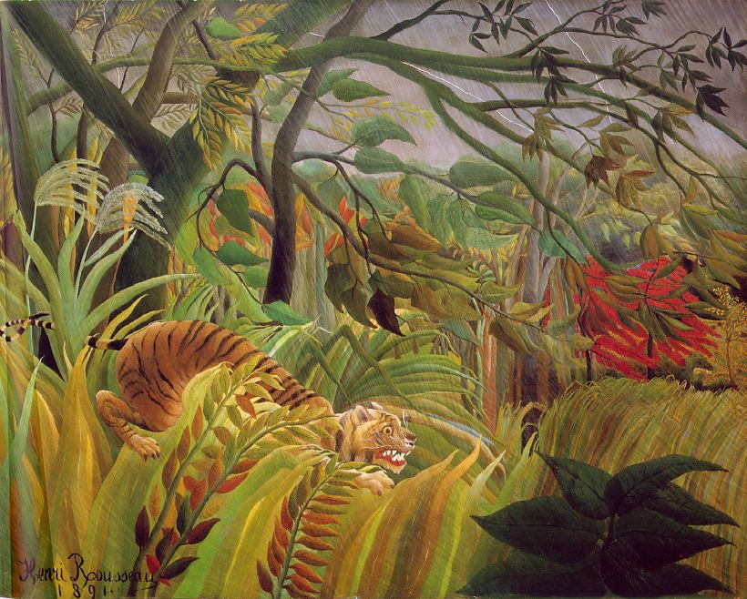
A drawing in the style of Henri Rousseau
Tiger in a Tropical Storm

What is your drawing called? ................................................................................................................

