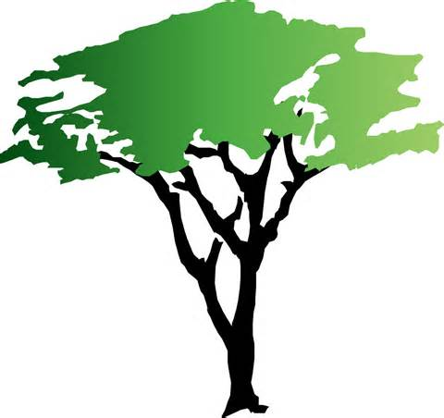
The Amazon Rainforest – South America
- The Amazon rainforest is the largest tropical rainforest in the world, covering over five and a half a million square kilometres. It's so big that the UK and Ireland would fit into it 17 times!
- Over half of the Amazon rainforest is located in Brazil but it is also located in other South American countries including Peru, Venezuela, Ecuador, Colombia, Guyana, Bolivia, Suriname and French Guiana.
- 10% of the world’s known species live in the Amazon rainforest.
- 20% (1,300) of the world’s bird species live in the Amazon rainforest.
- It is home to around 2.5 million different insect species as well as over 40,000 plant species,3,000 types of fish and 430 mammals.
- There are also a number of dangerous species living in the Amazon rainforest such as the cougar, jaguar and anaconda.
- Running through the north of the rainforest is the Amazon river. Flowing a length of around 6,400km, it is the longest river in the world.
- Around 400-500 tribes call the Amazon rainforest home. It's believed that about fifty of these tribes have never had contact with the outside world!
- More than 20% of the world’s oxygen is produced by the Amazon.
- Due to the thickness of the canopy (the top branches and leaves of the trees), the Amazon floor is in permanent darkness. In fact, it’s so thick that when it rains, it takes around ten minutes for the water to reach the ground!
- Latin American forests are home to black howler monkeys, whose calls can be heard almost 5km away!

Rainfall and temperatures in the Amazon
