Can I write a character description?

Internal Characteristics External Characteristics
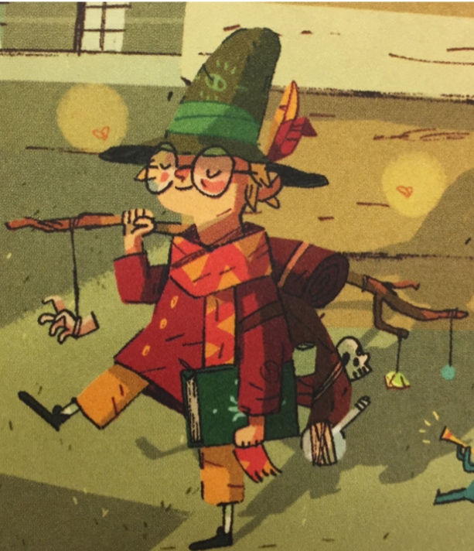
(personality and thoughts) (appearance, interests
talents, clothing)

Choose your challenge!
Bronze – Draw a picture of Arthur and write some adjectives to describe him
Silver - Draw a picture of Arthur and describe his internal and external characteristics

Gold - Write a paragraph (correctly punctuated describing Arthur. Refer to internal and external characteristics. Draw him!

