

**Climbing**

Think about a time when you climbed up something, e.g. a mountain, a hill, a tree, a climbing frame.

* How did you feel at the bottom, looking up?
* How did you feel as you climbed?
* How did you feel when you reached the top?
* What could you see?
* What could you hear?
* What was it like coming back down?
* Did you feel tired and breathless?
* Did you enjoy the climb? Why?

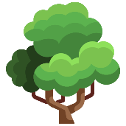

Describe your climb. You could use pictures, words and/or sentences.



Challenge yourself to include some interesting vocabulary.

summit peak breathless

approach enlivened steep

exhausted hauled explore