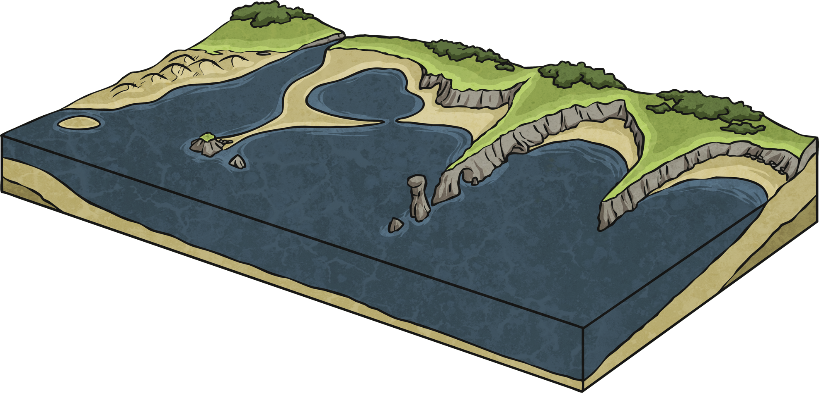

stump

stack

arch

headland

cliff

beach

spit

dune

bay

cave

coast