Year 4 – Independent/Home Learning Tasks
Wednesday 13th January 2021
It’s been a very steep learning curve for all of us so far. Thank you to all parents who have managed to get your child to complete some learning. Things will get easier as we go and this week I have set the meetings on repeat so you will just have the one email with the links sent. Click on the same link for the lesson of your choice (time-wise) every day.
It is important that you do some learning every day so that we don’t get behind.
Your parents can email me if they have any problems.
tmcdaniel@attleboroughprimary.org.uk
Any resources you need for lessons will be on the school website. Click on the ‘parent’ tab, then ‘home learning’ and your ‘class’ page. Here are today’s learning tasks!
Live Lessons (via Teams)
English : We look forward to you joining us for English at: 9.15am or 9.45am  Follow up activity after lesson:  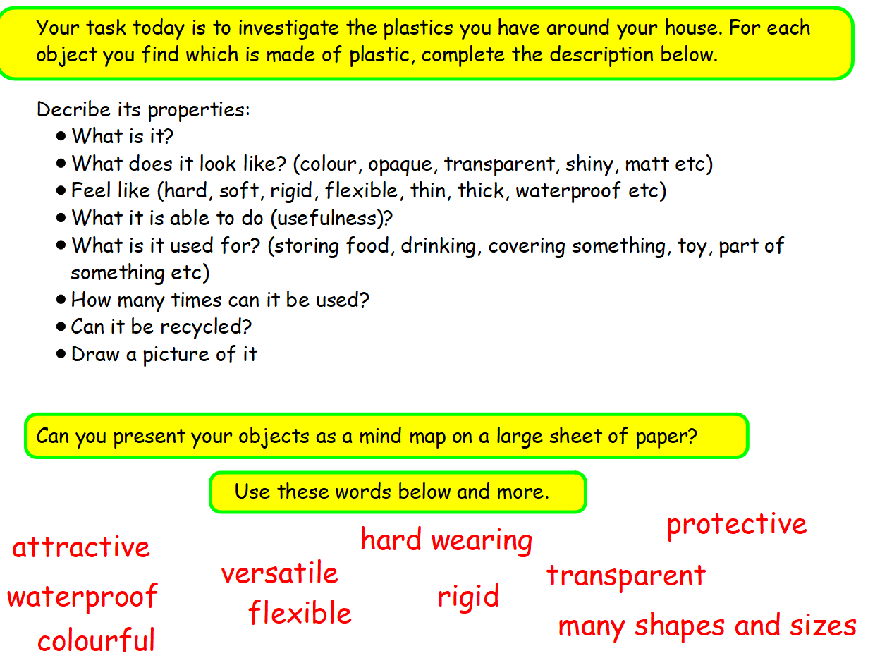 | Maths: We look forward to you joining us for maths at: 10.15am or 10.45am  Follow-up activity after lesson:  Complete tasks on website/email  Task sheet bronze  Pg37 Silver  Pg38 Gold | Reading: When the Mountains Roared  We look forward to you joining us at:  1.15pm or 1.45pm  Follow-up activity after lesson:  Draw a picture from something in the story
Spellings | Reading | Be Active
leisure  marvellous  mischievous  necessary  nuisance  persuade  Practise writing your spellings in as many different ways as you can eg: writing, drawing, typing, with sticks, chalk, paint, pens  Alphabet game – Write out the letters of the alphabet down the side of a piece of paper. Can you think of a sport that starts with each letter? Play the game again changing the theme to animals, countries or foods etc | Please read every day for at least 10 minutes.  How many of the Reading Bingo (attached below) challenges can you complete this week? | Stretching – these are great to do once you wake up or before bed. Start from your head and hold a stretch comfortably for 10 seconds. Work your way down to your toes and enjoy feeling refreshed and calm.
Other Curriculum Learning
Our Topic this term is learning about the North and South Pole (The Ends of the Earth). For this week, if you can start to find out as much as you can about these places, that would be great. I will be using Google Earth in my first lesson on this (you could have a sneak preview, if you want to, yourselves)
Also search for David Attenborough’s Frozen Planet on BBC IPlayer, it’s amazing!
Also on IPlayer is a series called Perfect Planet by David Attenborough. Series 1 Episode 2 (The Sun) talks about climates of the Earth and the Poles and why temperature around the planet varies. Watch that too!
Useful Websites for extra learning
BBC Bitesize have daily lessons for in all areas of the curriculum. https://www.bbc.co.uk/bitesize
Lockdown learning on BBC IPlayer
Maths – https://www.topmarks.co.uk
Reading – https://www.boodtrust.org.uk/Books-and-reading/have-some-fun/storybooks-and-games/
Writing – www.pobble365.com
Internet Safety: https://www.thinkuknow.co.uk
Computing – https://www.ictgames.com
Well-Being https://www.activenorfolk.org/active-at-home-kids
YOGA https://www.youtube.com/results?search_query=cosmic+kids+yoga+club

Reading Bingo
