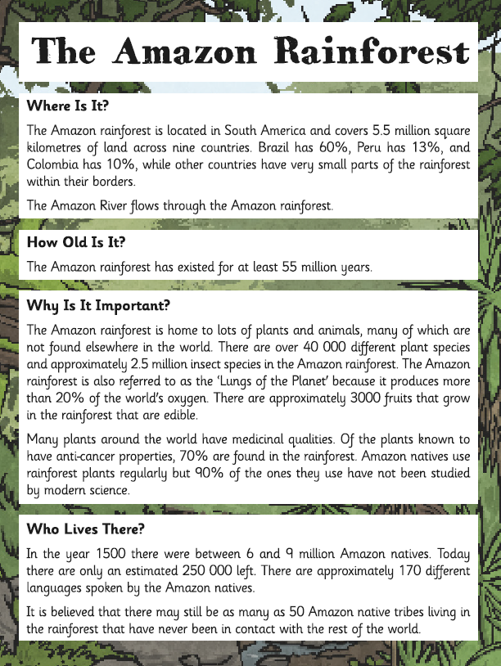

Thetford Forest
Where is it?
Thetford Forest is located on the border of Norfolk and Suffolk in the heart of Breckland in East Anglia. Major roads leading to Thetford Forest are the M11 from London, the A11 from Norwich or Newmarket and the A14 from Cambridge or Ipswich. It covers 18,730 hectares. A river called the Little Ouse runs through part of the forest.
How old is it?
Thetford Forest is the largest man-made pine forest in the United Kingdom and covers an area about the size of a city. The first trees were planted after the First World War in the 1920s by the Forestry Commission, it forms a large part of the history of the Brecks landscape.
Why is it important?
Thetford Forest was created after the First World War to provide a strategic reserve of timber, since the country had lost so many oaks and other slow-growing trees as a consequence of the war's demands. It is managed by the Forestry Commission.
From at least the fourteenth century, large areas were used for warrens, and the intensive grazing of rabbits lead to the formation in places of mobile sand dunes. In the 1760s the area was described as 'sand, and scattered gravel, without the least vegetation; a mere African desert'. It looks very different now although you can still see some sand dunes!
Breckland boasts some of the most important sites of historical interest in the country, not least 5,000-year-old Grime’s Graves, the only Neolithic flint mine open in Britain.
The site of Lynford in Thetford Forest, where a group of gravel pits are located on a flood plain terrace on the south bank of the River Wissey, is one of the best preserved late Middle Palaeolithic sites in Britain and the most important Neanderthal site in the whole of the British Isles.
In 2002 archaeological investigation revealed evidence of early human activity in direct association with mammoth bones dating back 65,000 years. Black flint hand axes were found within the same layer of sediment as the remains of at least nine woolly mammoths, marking Lynford as the only recorded mammoth butchery site in Britain
Who lives there?
The historical market town of Thetford is home to nearly 25,000 people today. The Domesday Book of 1086 estimated the population of Thetford to have grown to between 4000 and 4500 people, which would have been the sixth largest town in Britain at the time.

Use the information from the forest fact sheets to compare the two forests.
 | Thetford Forest | Amazon Rainforest
Location
Age
Size
River(s) passing through it
Plants/trees
Animals
Inhabitants
What is it important or famous for?

