Bronze:
Make yourself some place value cards or print out the ones below. Randomly select three to make a 3 digit number. Then repeat. Can you use the correct crocodile mouth between them? Remember the smaller number always eats the bigger number! If you want to challenge yourself, try to write a 3 digit number that would be between your numbers. Try 10 of these.

1 | 2 | 3
4 | 5 | 6
7 | 8 | 9

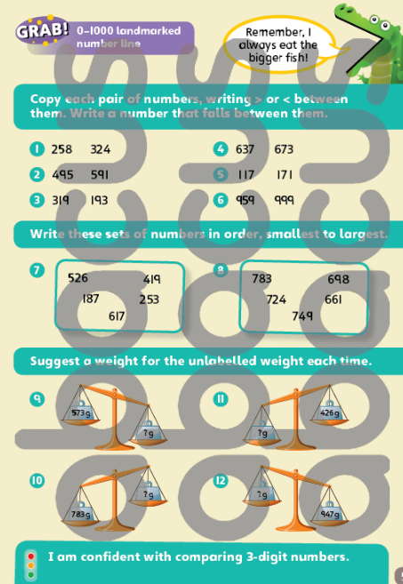
Silver

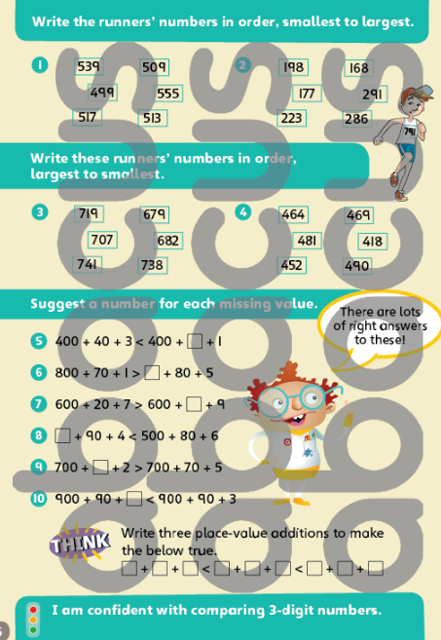
Gold

