lire | 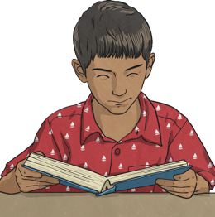 | reading
manger | 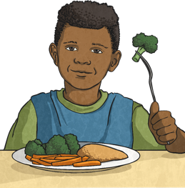 | eating
courir | 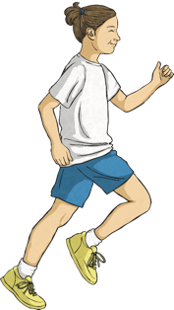 | running
chanter |  | singing
marcher | 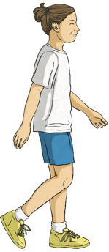 | walking
jouer au foot | 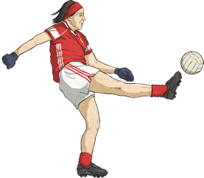 | playing football
parler avec mes ami(e)s | 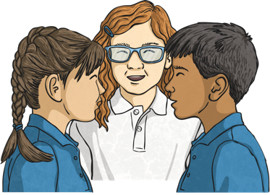 | talking with my friends
travailler sur l’ordinateur | 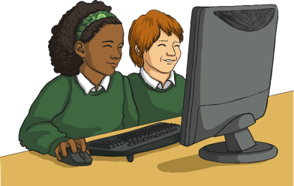 | working on the computer
jouer au basket | 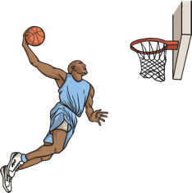 | playing basketball
aider le professeur | 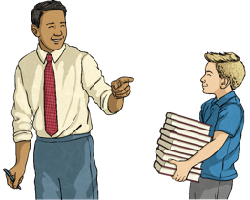 | helping the teacher

- J’aime ________________________________________________________
____________________________________________________________________.
- J’aime ________________________________________________________
____________________________________________________________________.
- J’aime ________________________________________________________
____________________________________________________________________.
- J’aime ________________________________________________________
____________________________________________________________________.
- J’aime ________________________________________________________
____________________________________________________________________.
- J’aime ________________________________________________________
____________________________________________________________________.

