Writing example:
Step by careful step, she plodded along the muddy track. The thick, cloying fog seemed to be following her, but she knew that wasn’t true. It moved all around her, in and amongst the trees and across the path ahead of her; it was just another problem for her to overcome.
She had travelled such a long way. Such things she had seen along the road…things she never wished to talk about. Not that that was likely. It had been over two weeks since she had seen another living soul. Nowadays, the road that was once so busy with travellers was now seemingly abandoned.
Holding her crooked staff in her left hand for support, and her rusty, reliable lantern in her right, the old lady took another step towards her destination. Her feet were wet and tired, and she could feel what was the beginning of a blister forming on the soul of her left foot; this was yet another problem. They seemed endless these days.
She sighed, realising that there was still so far to go.

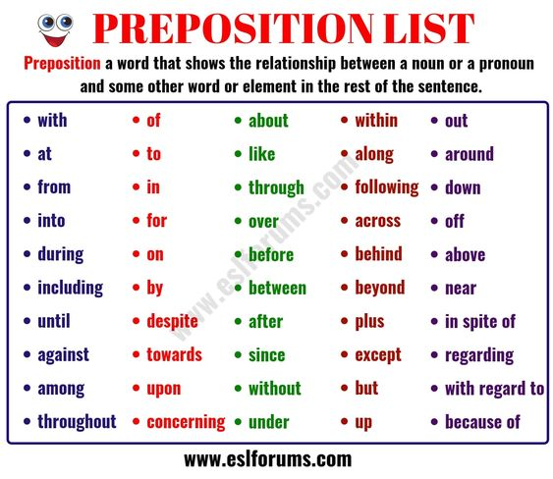

Subordinating conjunctions
