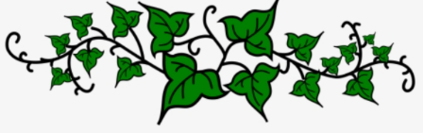
The Secret Garden
Make your own “double page spread” of The Secret Garden. You could talk about the plot, themes, characters, the setting… anything in fact which gives an insight into the book! Make it really eye-catching and colourful. Remember that you can use extra paper to add interest – for example, you could add an envelope with extra information, pull-up flaps, and so on.
This is a competition – there will be a winning entry chosen in each class.
Closing date: Friday 19th March.
Email your entries (you can take a picture an upload them to email) to: ltovell@attleboroughprimary.org.uk
Or – if you are in school – bring them to me!
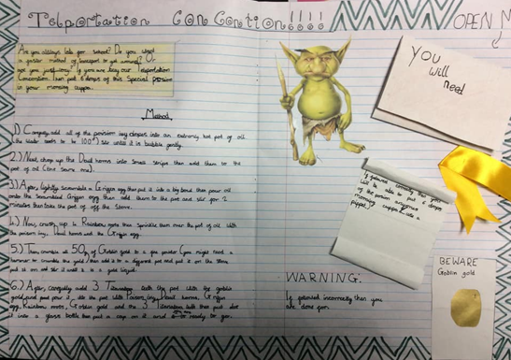
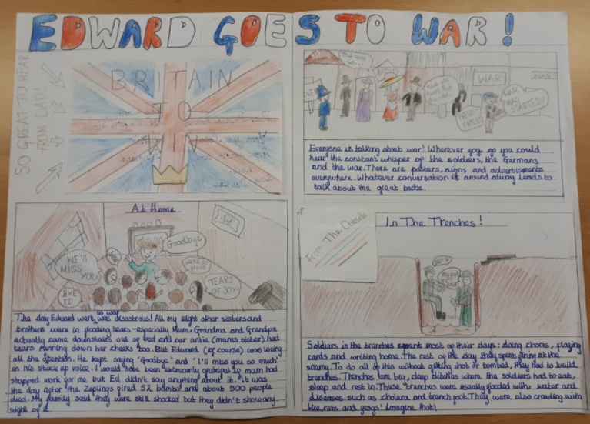
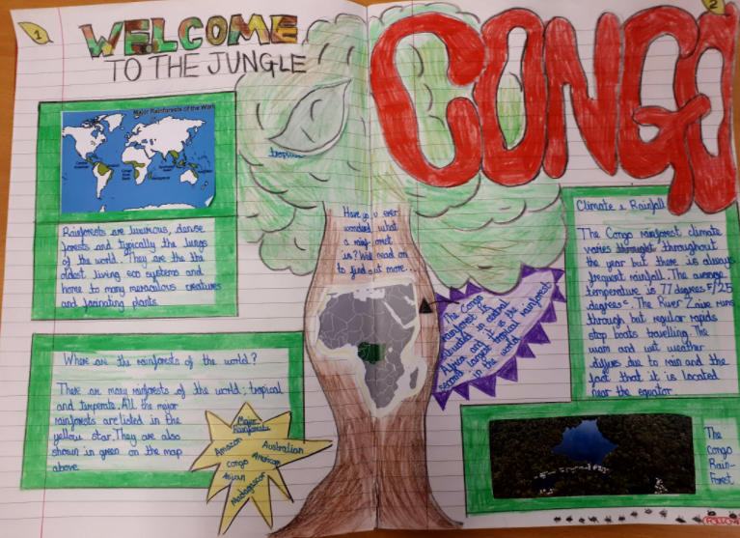
Here are some examples of double page spreads for ideas…
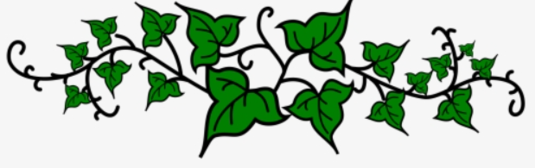
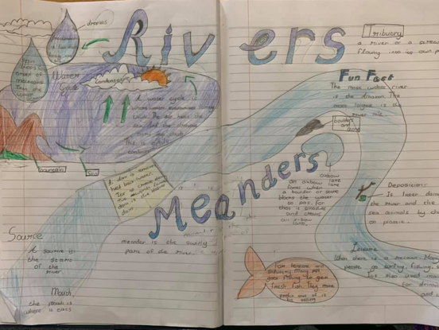
Good luck!

