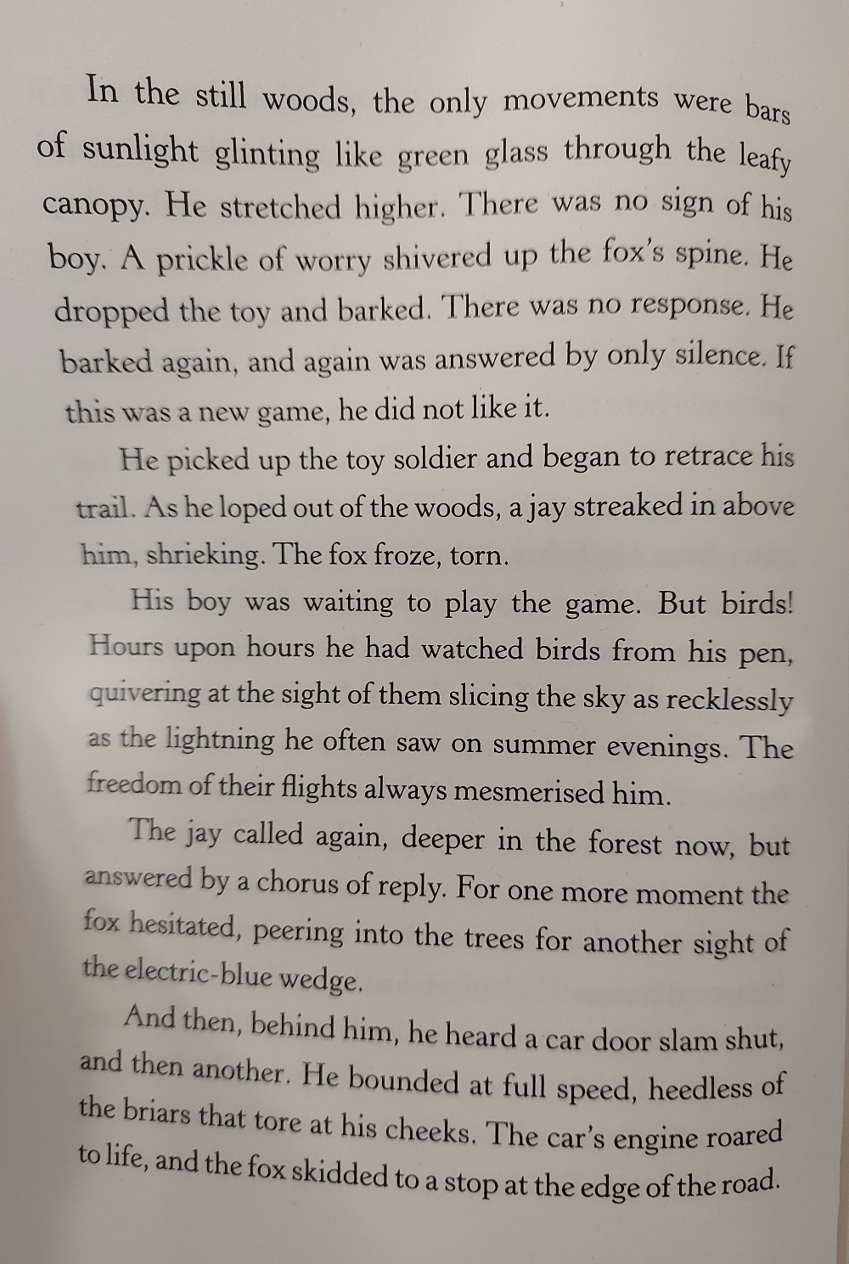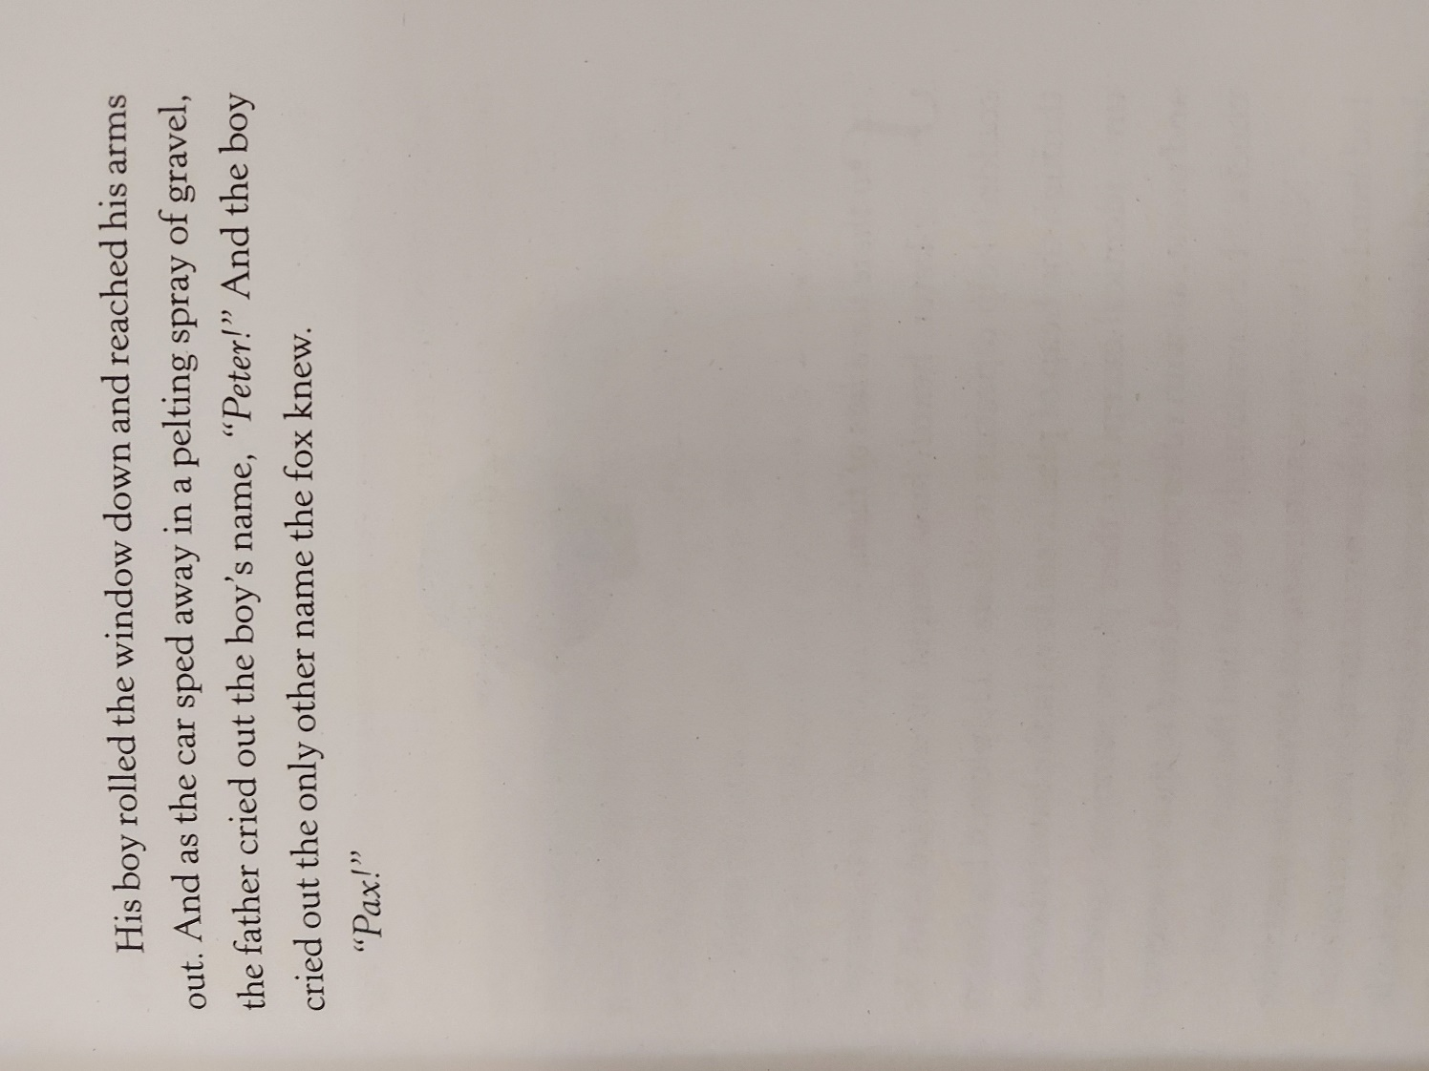

Re-read the text from the end of chapter one. Think about how the author shows the fox's heightened awareness of the shifting mood in the wood. How does the fox feel at this point in the story?

Draw this scene – you can use any media you have – coloured pencils, pens, chalks, paints, collage materials – it’s up to you! On your artwork, add a word or phrase which sums up how Pax is feeling at this point.