Year 3 – Independent/Home Learning Tasks
Monday 11th January 2021
Today’s learning tasks!
Live Lessons (via Teams)
English : We look forward to you joining us for English at: 9:15 or 9:45am  Follow up activity after lesson:  Write your version of a ‘Book’s are…’ poem. Then illustrate it!  “Books are key to wisdom’s treasure  Books are gates to lands of pleasure  Books are paths that upward lead  Books are friends: come let us read”  by Emilie Poulsson | Maths: We look forward to you joining us for maths at: 10:15 or 10:45am  Follow-up activity after lesson:  Multiplying and Dividing by 10 questions (see website) | Internet Safety Lesson: We look forward to you joining us at: 1:15 or 1:45pm  Follow-up activity after lesson:  Complete ‘Keep it Private’ form
Spellings | Reading | Be Active
Apologies for wrong spellings on Friday’s sheet.  These are your new spellings! Test Friday!  Group 1  thought, through, weight, woman, women  or  Group 2  after, again, any, bath, beautiful | Please read today for at least 10 minutes.  Draw a picture of your favourite part of your book and describe what you have drawn | Do you or a sibling have a ball pit? How long does it take you to empty the balls (only using your hands and not touching the pit). Try it one handed, try only taking some colours out at a time, try it only using your feet! Turn it into a family competition!  OR  Hopscotch – Have a dry pavement and a piece of chalk? Draw your own outside!
Other Curriculum Learning
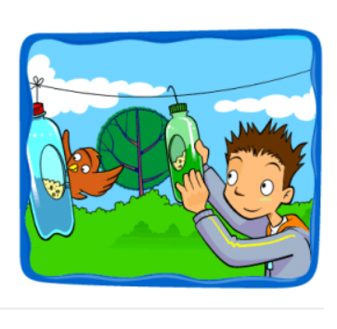
Well-Being - Make it Monday! – Get Creative and get your week off to a
fantastic start. Make a recycled bird feeder from an empty plastic bottle
for your garden or windowsill.
https://www.activenorfolk.org/active-at-home-kids
Tackling Tables – During lockdown try and tackle those Times Tables.
Practise online or make up some games to help you
Useful Websites for extra learning
BBC Bitesize have daily lessons in all areas of the curriculum. https://www.bbc.co.uk/bitesize
Maths – https://www.topmarks.co.uk
Reading - https://www.booktrust.org.uk/Books-and-reading/have-some-fun/storybooks-and-games/
Writing – www.pobble365.com
Internet Safety: https://www.thinkuknow.co.uk
Computing – https://www.ictgames.com
Well-Being https://www.activenorfolk.org/active-at-home-kids
Teacher Contact details for any queries and emailing work!
kfaulkner@attleboroughprimary.org.uk
abarker@attleboroughprimary.org.uk
cthelwell@attleboroughprimary.org.uk
athompson@attleboroughprimary.org.uk

