Year 3 – Independent/Home Learning Tasks
Thursday 14th January 2021
Today’s learning tasks!
Live Lessons (via Teams)
English: We look forward to you joining us for English at: 9:15 or 9:45am  Follow up activity after lesson:  Being a story-teller!  Entertain your family by re-telling a story you know well or spend some time making one up!  No need to write anything down, this is all about making a story sound exciting, funny or scary!  You could draw a story map to help you remember your story  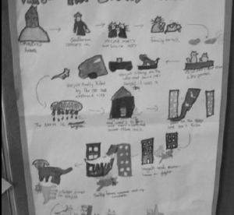 | Maths: We look forward to you joining us for maths at: 10:15 or 10:45am  Follow-up activity after lesson:  Place Value – Consolidation and solving problems.  Tic-Tac-Toe worksheet (see website)  Bronze: Page 1 and 2  Silver: Page 3 and 4  Gold: Pages 5 and 6  How about making up your own place value problem game! | Topic: Rainforest: We look forward to you joining us at: 1:15 or 1:45pm  Follow-up activity after lesson:  Write a postcard to your class pretending that you are on holiday in the rainforest. Make sure you tell them what the climate is in the rainforest and what it is like being there.  Bronze: Make sure your capital letters and full-stops are correct  Silver: Include some good adjectives to add to your descriptions  Gold: Include geographical words eg: humid, season, climate, rainfall, tropics, equator  Don’t forget to draw a picture to go with our writing!
Spellings | Reading | Be Active
These are your spellings!  Test Friday!  Group 1  thought, through, weight, woman, women  or  Group 2  after, again, any, bath, beautiful | Please read today for at least 10 minutes.  New Words - Write down any new words you have not heard before from your book. Use a dictionary to record their meaning | Dance: Can you do the Triangle Dance? Try it with members of your family! Hint: there are 3 jumps and each of you jump either forward, right or left at the same time! Watch this video to help you! The Triangle Dance - Moose Tube | GoNoodle - Bing video
Other Curriculum Learning
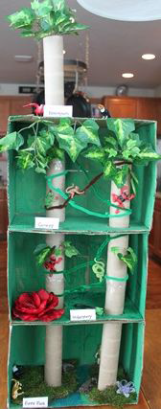
Topic: Rainforest – Have you painted your diorama? Send an email to show
us your finished creation!
French: Can you remember how to say hello and goodbye. Can you count to 10
and write the numbers down – spelt correctly!
Well-Being: Time Table Thursday!– Keep your brain active with a fun learning
activity. Play a board game like connect 4
Tackling Tables – Keep practising. Make up a game, song or rhyme to help you learn a tricky times Table
CBBC Programmes Today:
Celebrity Supply Teacher – 10:05 - Gardening
Art – 11:05 – Art Ninja
Science - 11:35 – Operation Ouch! Don’t pick your scabs! Adds nicely you our Animals, including humans unit!
Useful Websites for extra learning
BBC Bitesize have daily lessons in all areas of the curriculum. https://www.bbc.co.uk/bitesize
Maths – https://www.topmarks.co.uk
Reading - https://www.booktrust.org.uk/Books-and-reading/have-some-fun/storybooks-and-games/
Writing – www.pobble365.com
Internet Safety: https://www.thinkuknow.co.uk
Computing – https://www.ictgames.com
Well-Being https://www.activenorfolk.org/active-at-home-kids
Teacher Contact details for any queries and emailing work!
kfaulkner@attleboroughprimary.org.uk
abarker@attleboroughprimary.org.uk
cthelwell@attleboroughprimary.org.uk
athompson@attleboroughprimary.org.uk

